SDLC Models

Waterfall Model –
The Waterfall Model is the oldest and simplest SDLC model.
It works in a step-by-step (linear) way.
You finish one step completely, then move to the next.
You cannot go back to a previous phase easily.
It is called Waterfall because work flows downwards like a waterfall.
Phases
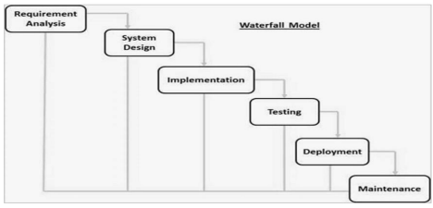

• Requirement Gathering
• Collect all requirements.
• Make a document of what the software should do.

• System Design
• Plan how the system will work.
• Decide hardware, software, database, and architecture.

• Implementation (Coding)
• Write the code.
• Develop small units and test them (Unit Testing).

• Integration & Testing
• Combine all units.
• Test the whole system for errors.

• Deployment
• Deliver the software to the customer or release it.

• Maintenance
• Fix issues found by users.
• Release updates and improvements.
When to use Waterfall :
1. Requirements are clear and fixed
2. Technology is stable
3. Small and simple projects
4. No frequent changes
Advantages:
1. Very simple to understand
2. Easy to manage
3. Each phase has clear steps
4. Good for small projects
5. Everything is well-documented
Disadvantages:
• Cannot make changes easily
• Not good for long or complex projects
• Working software comes very late
• High risk if requirements change
• Problems are found very late (big-bang integration)

Agile Model –
Agile Model is a software development method where work is done in small parts called iterations.
Each iteration is usually 1–3 weeks and produces a working piece of software.

Agile focuses on:
• Quick delivery
• Customer feedback
• Flexibility
• Continuous improvement
How Agile Works
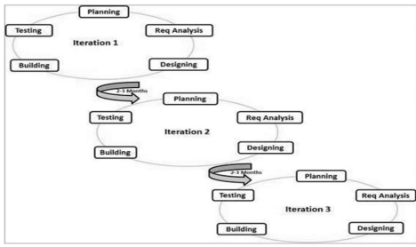

Each iteration includes:
1. Planning – Decide what features to build.
2. Requirement Analysis – Understand what the customer wants.
3. Designing – Plan how the feature will work.
4. Coding – Developers write the code.
5. Testing – Check if the feature works correctly.
6.Delivery – Show the working product to the customer.
At the end of every iteration, a working product is shown to the customer, and changes can be made immediately.
Agile Principles
1. People over paperwork
2. Working software over long documentation
3. Customer involvement at every step
4. Easy to respond to changes anytime

Agile vs Traditional (Waterfall)
• Agile = Adaptive, changes allowed anytime
• Waterfall = Predictive, changes difficult
• Agile does small releases frequently
• Waterfall has one big release at the end

Advantages of Agile
• Fast delivery of software
• Easy to make changes
• Customer is involved throughout
• Early detection of problems
• Teamwork improves
• Small working software is delivered early

Disadvantages of Agile
• Not good for very large, complex projects
• Needs a customer who gives regular feedback
• Less documentation
• Hard for new team members to understand old work
• Requires an experienced team

What is Agile?
Agile means breaking the project into small parts, delivering a working product after every small step, and changing things quickly based on customer feedback.

V-Model –
The V-Model is an SDLC model where development and testing happen in parallel. It looks like the letter “V” because:
• Left side = Development (Verification)
• Right side = Testing (Validation)
• Bottom = Coding
For every development stage, there is a matching testing stage. It is also called the Verification & Validation Model.

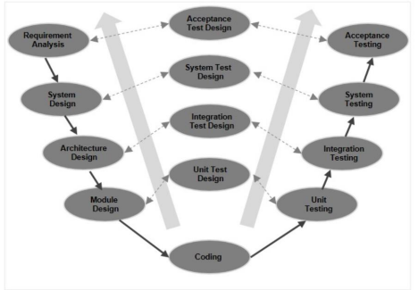

Left Side: Verification (Development Phases)
1. Requirement Analysis
a. Understand what the customer wants.
b. Plan Acceptance Testing.
2. System Design
a. Plan the whole system.
b. Prepare System Test plan.
3. Architecture / High-Level Design
a. Break system into major modules.
b. Plan Integration Test.

4. Module / Low-Level Design
a. Design each small module.
b. Prepare Unit Test cases.
5. Coding
a. Write the actual code.
Right Side: Validation (Testing Phases)
1. Unit Testing
a. Test each small module separately. b. Matches with Module Design.
2. Integration Testing
a. Check how modules work together.
b. Matches with Architecture Design.
3. System Testing
a. Test the whole system.
b. Matches with System Design.
4. Acceptance Testing
a. Customer tests the product.
b. Matches with Requirement Analysis.

When to Use V-Model (Easy)
• Requirements are clear and fixed
• Technology is stable
• Small or medium projects

Advantages
• Simple to understand
• Easy to manage
• Highly disciplined
• Testing starts early (parallel to development)

Disadvantages
• Not flexible to changes
• Changes are costly
• Not good for large or complex projects
• Working software comes late

In One Line:
V-Model = Waterfall + Testing planned early + One testing phase for every development phase.

Spiral Model –
The Spiral Model combines:
• Iterative development (repeat in cycles)
• Waterfall model (step-by-step structured process)
• High focus on risk analysis
In this model, the software is developed in loops, called Spirals.
Each spiral delivers an improved version of the product.
Four Phases of Spiral Model
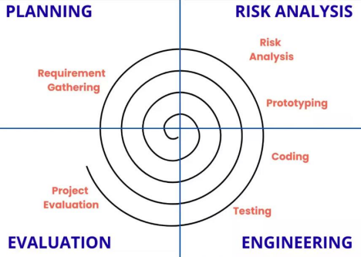

1. Planning (Identification)
• Collect business requirements.
• Later spirals: collect system, subsystem, and module requirements. • Customer and analyst discuss continuously.
• After a spiral ends, product version is delivered.

2. Risk Analysis
• Check possible risks:
o Technical risks
o Cost & schedule risks
• Build prototypes to reduce risk.
• Decide if the project should continue or stop.

3. Engineering
• Do design (architecture, module design).
• Coding of the build/version.
• Test the build.
• Each spiral gives a working version.

4. Evaluation
• Customer tests the build.
• Gives feedback.
• Based on feedback → next spiral starts with changes.

Where Spiral Model Is Used
Use it when:
• Requirements are not clear
• Project has high risk
• Customer needs regular builds
• Long-term, large projects
• Need frequent changes
• New product line (needs customer feedback)

Advantages (Pros)
• Easy to add new requirements
• Best model for risk management
• Customer sees the system early
• Uses prototypes
• Complex requirements become clearer
• Develop riskier parts first
• Supports multiple builds and releases
Disadvantages (Cons)
• Management is difficult
• Costly for small projects
• Project end date not clear
• Process is complex
• Spiral may go on indefinitely
• Too much documentation
• Requires expert risk analysts

In One Line:
Spiral Model = Iterative development + Waterfall structure + Strong focus on risk analysis.

